The columns in the pkl files are as follows:

1: APD data which will give us the normalized population ratio or "fraction" as its called in our code

2: CA data / CA+ data

3: CA- data

4: TTL trigger data

Concerning column 2/3 CA(Classical Accelerometer data): We have a CA that outputs differential signals to be used for calculating phase difference.

For most of the time, we run the two signals through a differential amplifier, which then outputs a single signal into CH B. In this case, our CH C will be unused and hence there is no data in column 3.

On some occasions, we do not have the differential amplifier, and have to use CH B and CH C, which gives us data in column 2 and 3. In this case, we have to use column 2 - column 3 (CA+ - CA-) to get the differential signal for phase calculation.

For each g measurement we have 2x79 runs, 79 for chirp up and 79 for chirp down. We scan the chirp rate at a randomized order, alternating between chirp up and down each time.

The 3 pkl files contains all the data for 2x79 runs, instead of 1 pkl file for each run. This is so that we can collect as much CA data as possible, even in-between each run.

The TTL trigger in the pkl files gives us the ability to sync each experimental run and extract the relevant data that we need.

The {}runtime_settings.json file is in each folder. This .json file gives us useful information for each run, such as the range of the picoscope channels, and the chirp scanning randomization order.

APD: Prelim Exploratory Data Analysis:

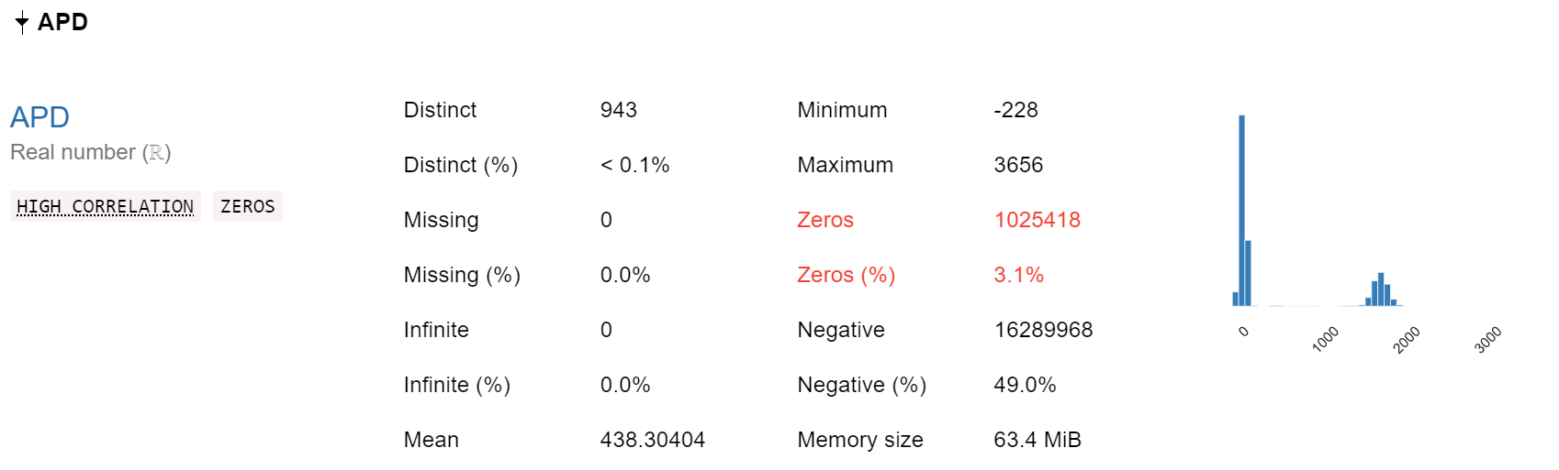

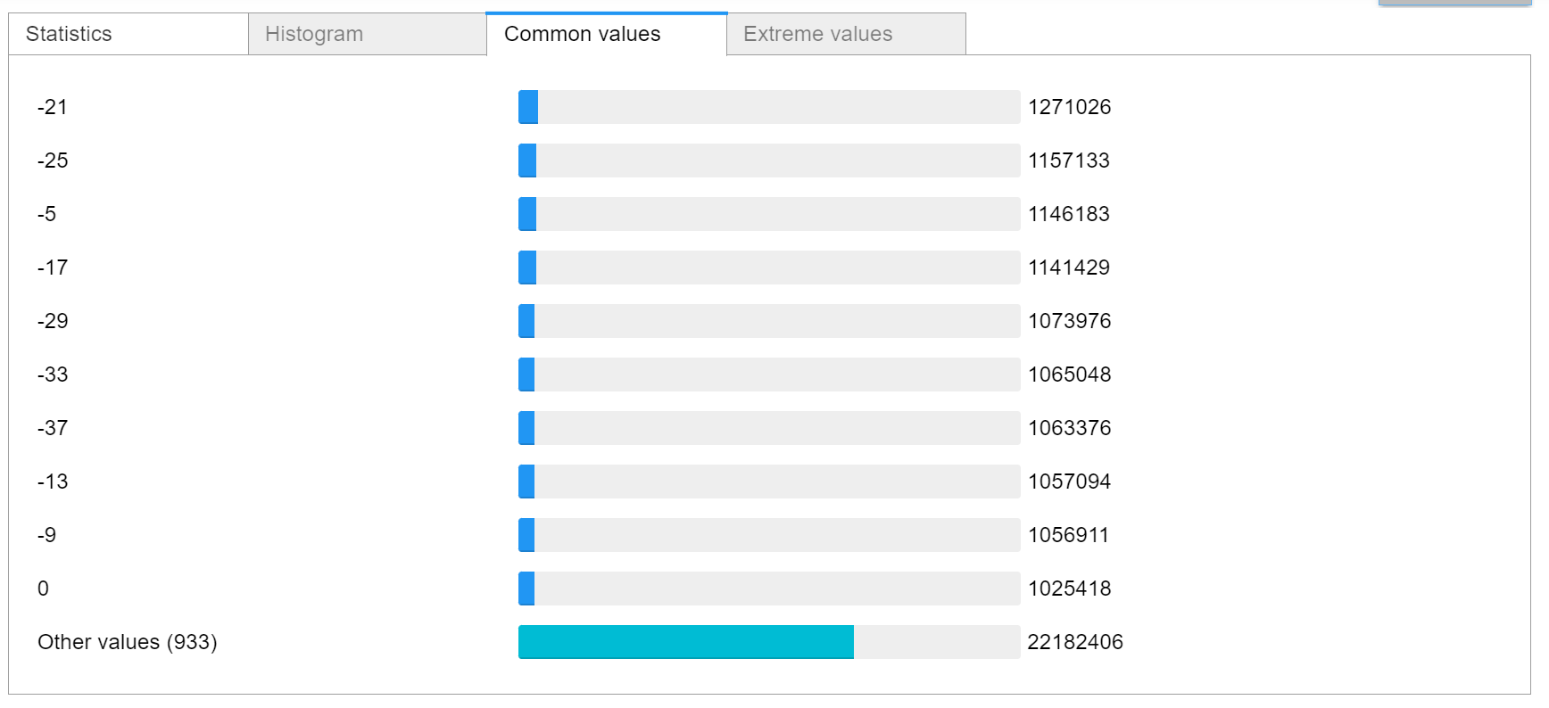

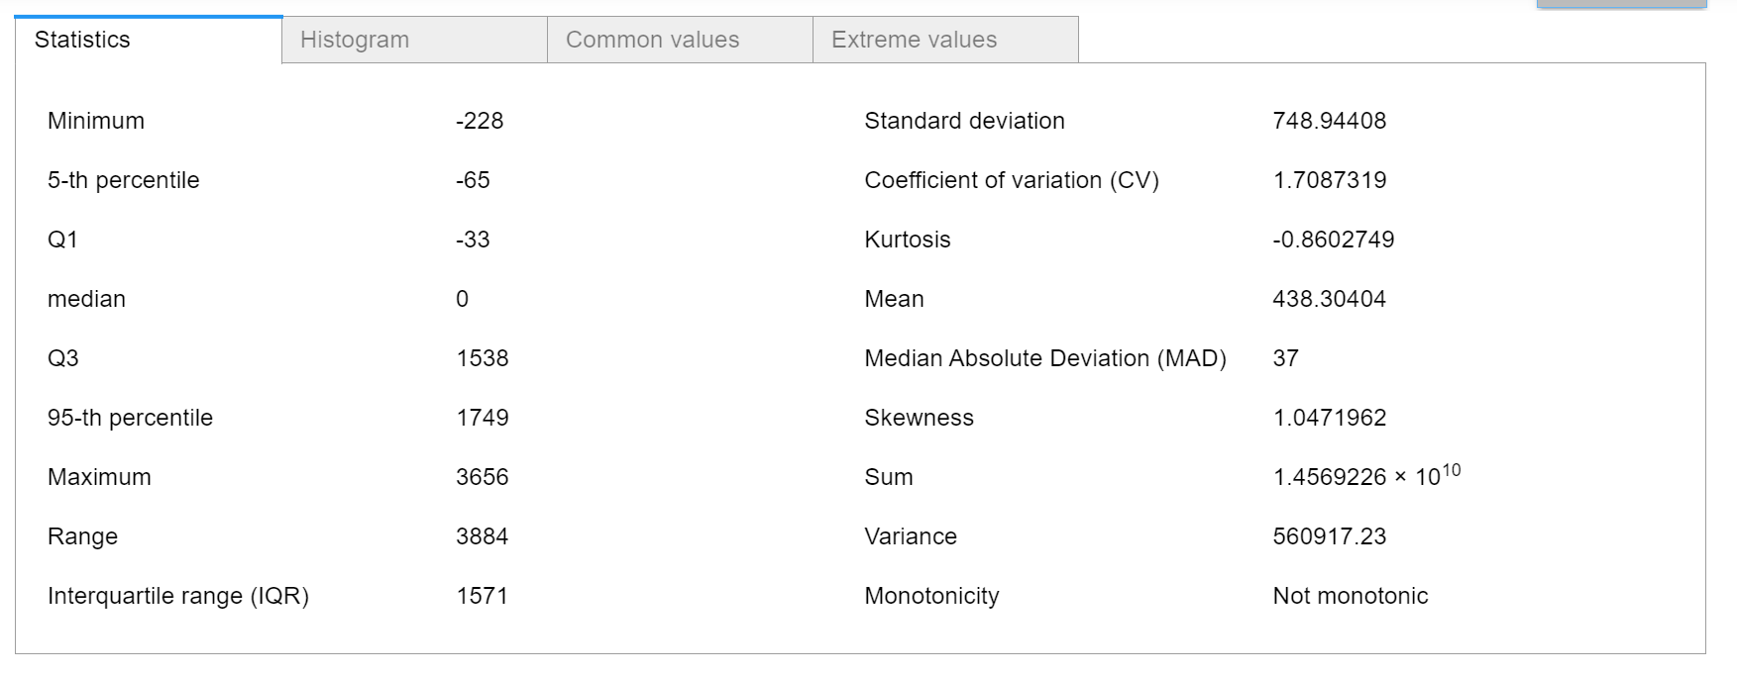

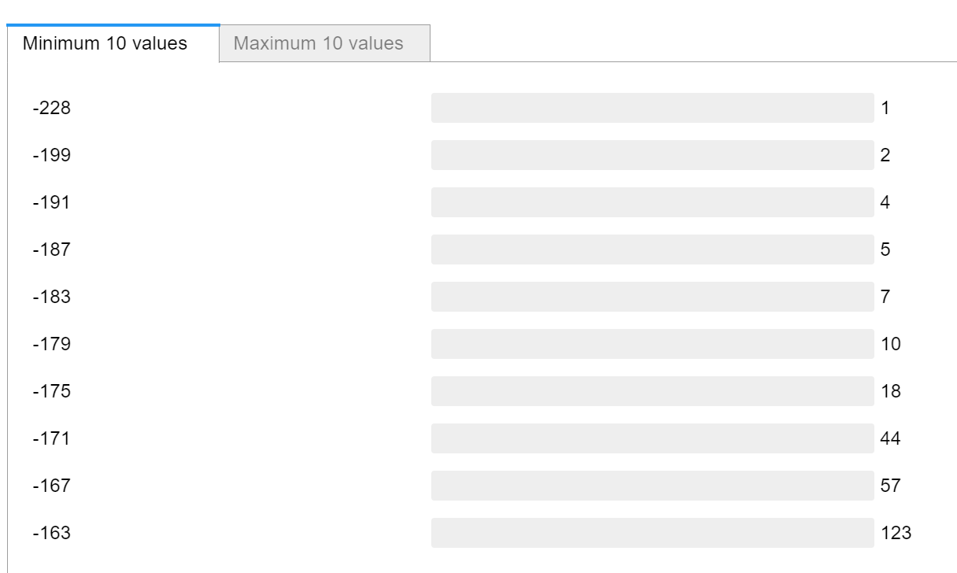

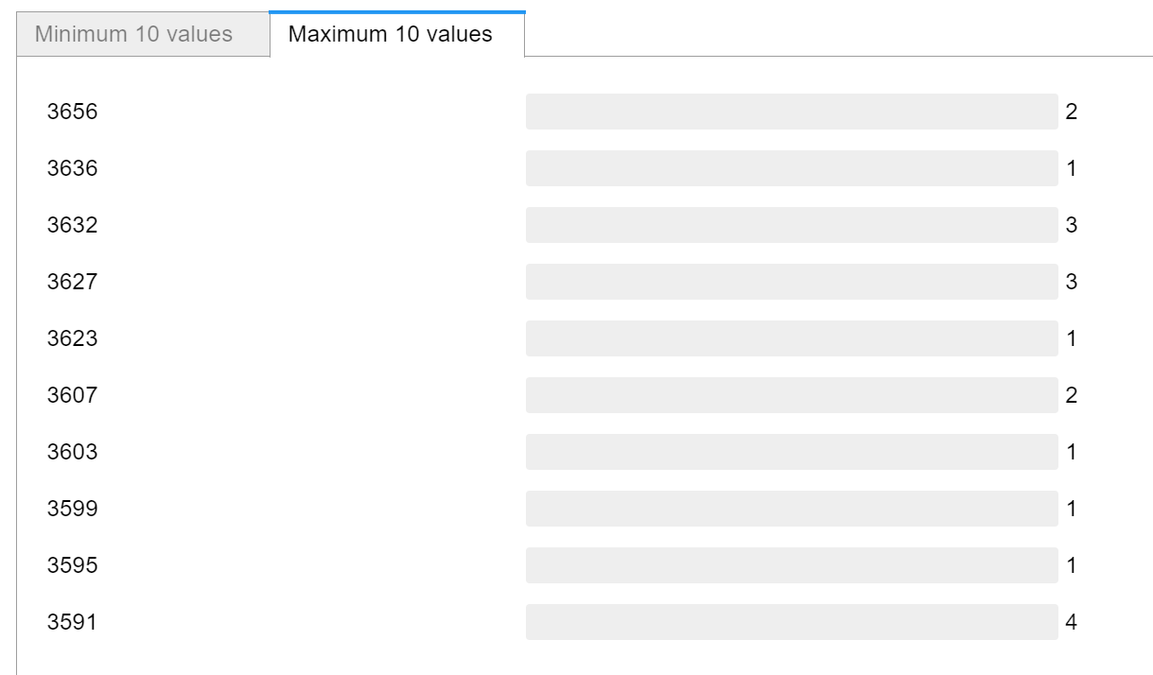

[ravi@atomionics.com](mailto:ravi@atomionics.com) Can you please write down the process to normalize the APD values.

I have defined Classical_Acc as difference between CA Plus or SRS and CA Minus

data['Classical_Acc'] = data['CA plus or SRS']- data['CA minus']

I am getting bimodal distribution:

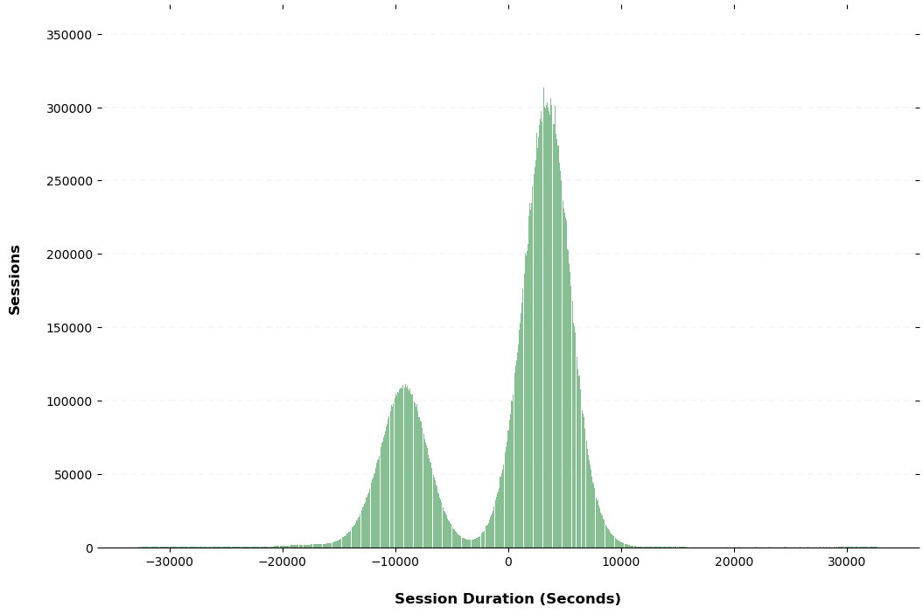

Similarly I am getting two lumps for APD Values:

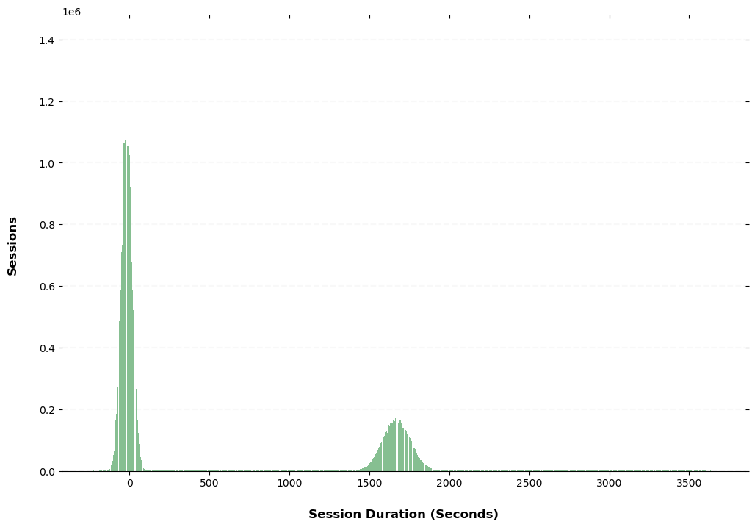

[ravi@atomionics.com](mailto:ravi@atomionics.com)Can you please write down the process to normalize the APD values.

APD Small (<240)

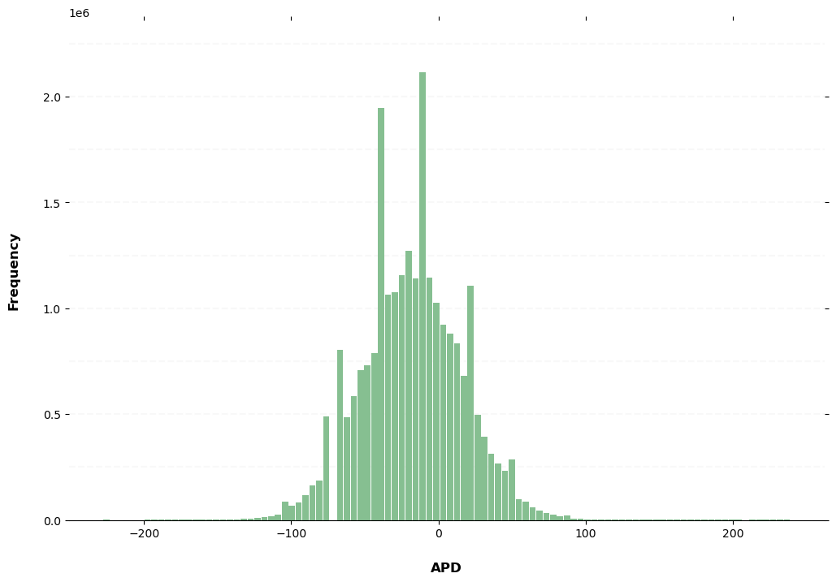

APD Big (>1400)

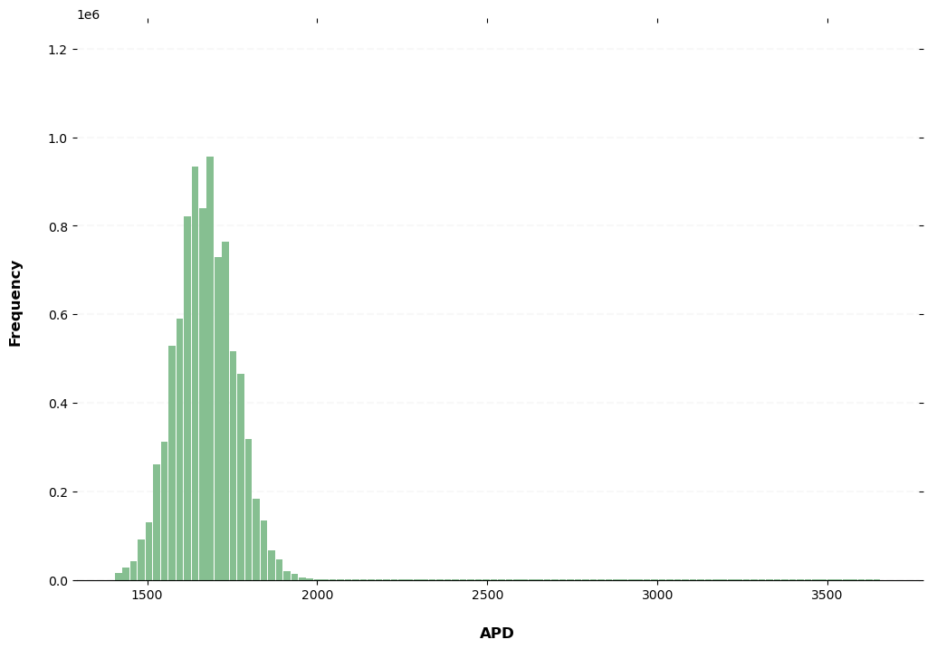

For Most recent data:

Classical Accelerator:

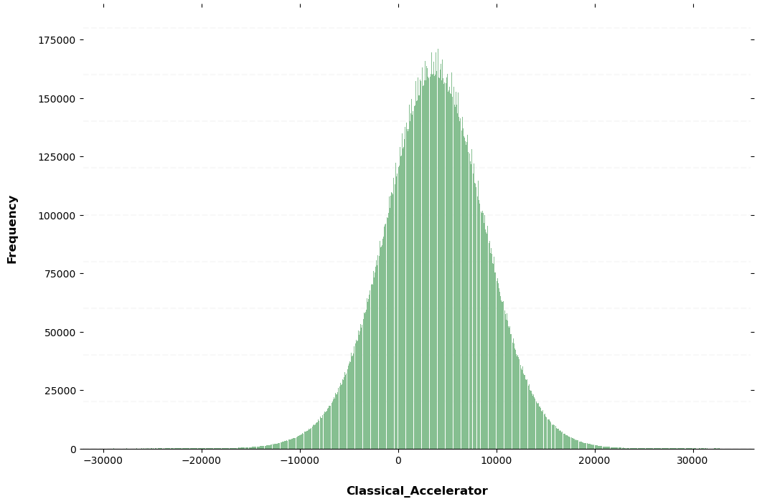

APD:  
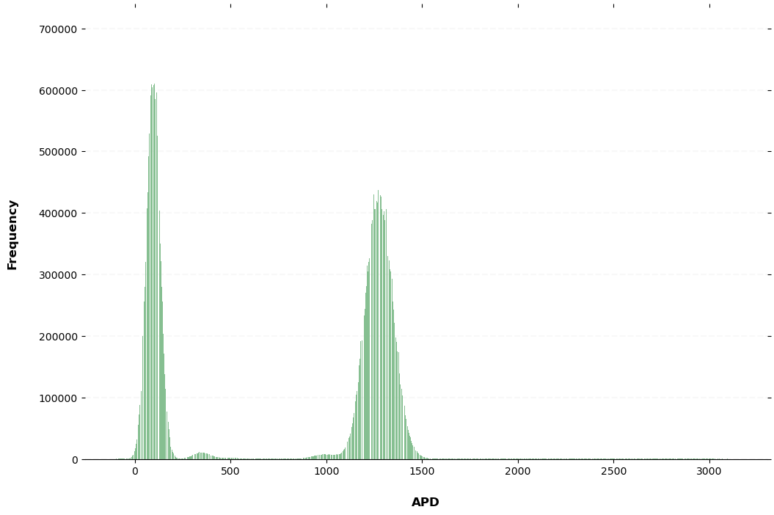

APD Small:(<500)

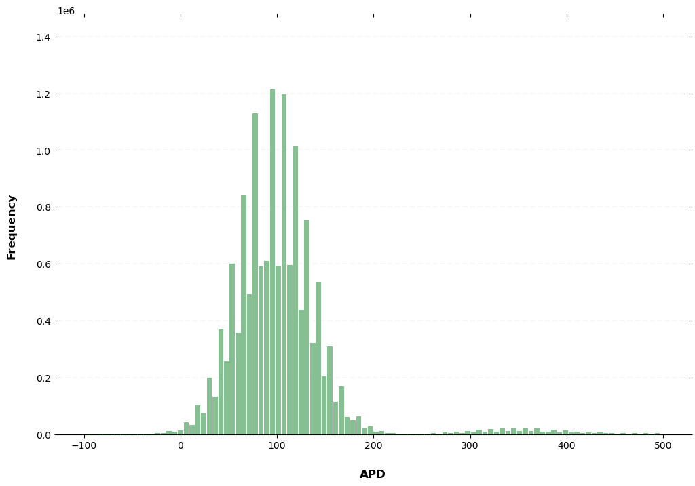

APD Big: (>500)

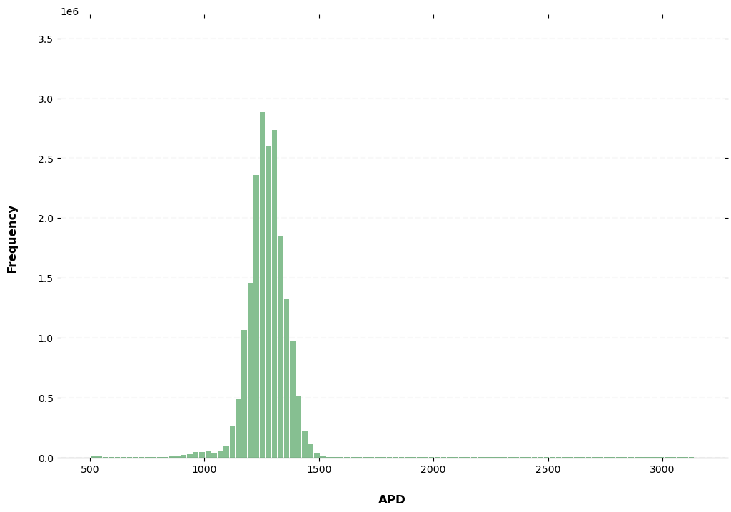

ADP Plot for first 10,000 rows

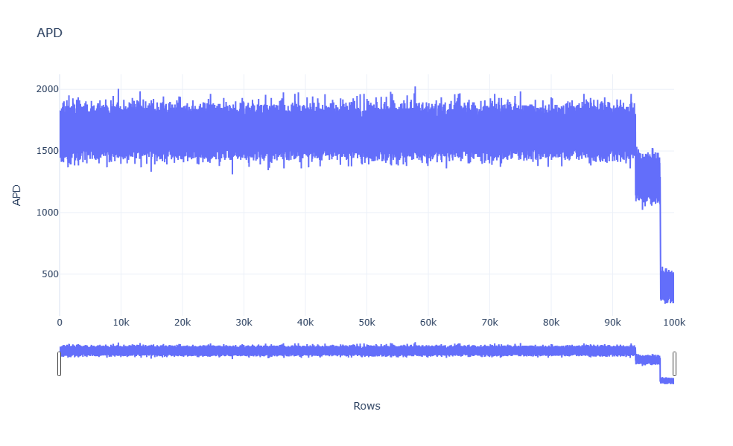

Zooming it:

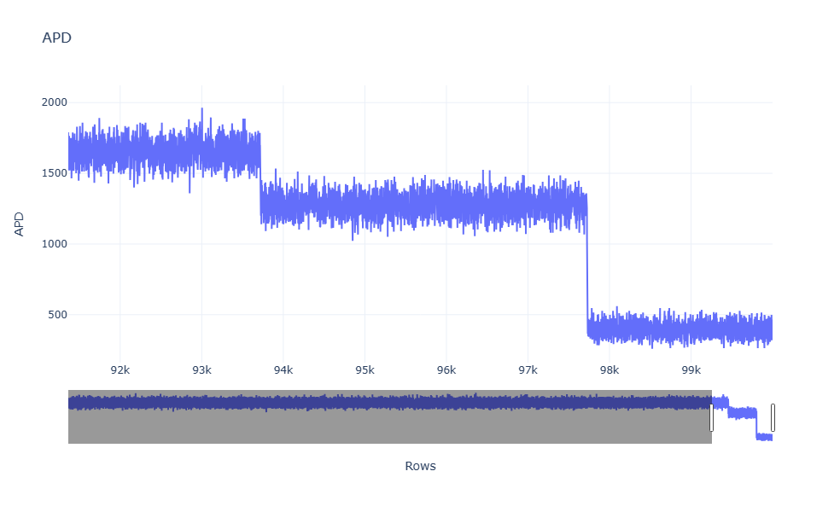

ADP Plot for first 1000,000 rows

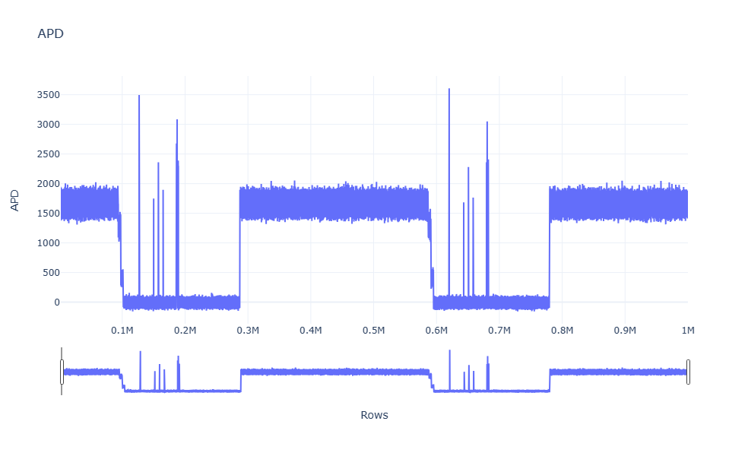

Classical Accelerometer (First 100,000)

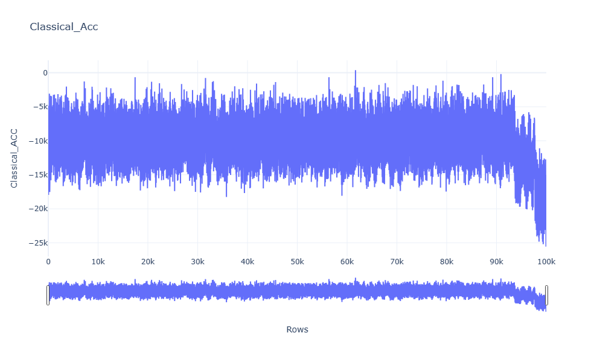

Zooming on the Graph:

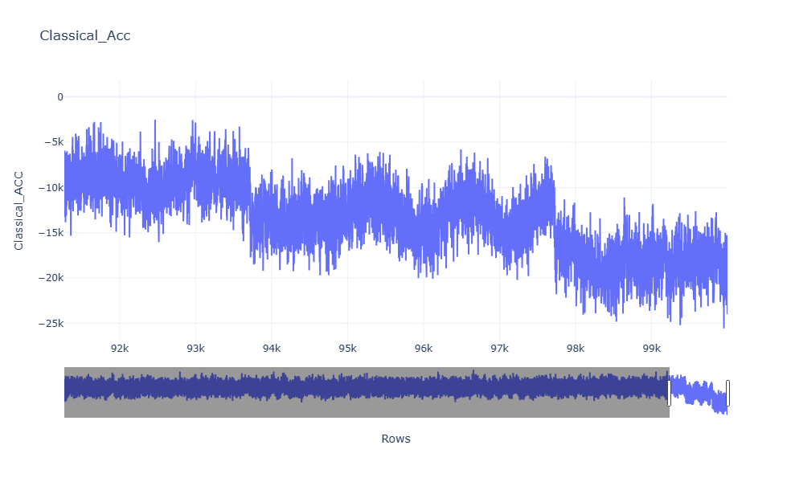

# Fringes Data and Gravity data:

After merging fringe data and gravity data we have a final dataset:

'master_run', 'run_number', 'current_repeats',

'total_repeats', 'var1', 'fraction', 'CA_phase', 'timestamp',

'uncorrected', 'corrected', 'corrected_vibration correction',

'corrected_chirp UpDown peak value',

'corrected_chirp UpDown peak error', 'corrected_chirp UpDown residual',

'corrected_chirp UpDown tilt correction',

'corrected_chirp UpDown tilt-corrected-g error',

'corrected_master range', 'corrected_time', 'corrected_master_run',

'uncorrected_vibration correction',

'uncorrected_chirp UpDown peak value',

'uncorrected_chirp UpDown peak error',

'uncorrected_chirp UpDown residual',

'uncorrected_chirp UpDown tilt correction',

'uncorrected_chirp UpDown tilt-corrected-g error',

'uncorrected_master range', 'uncorrected_time',

'uncorrected_master_run', 'Row'

Row column has been created to have serial number of the rows. The dataset has been sorted first by ‘master_run’ and then by ‘run number’.

The followings are the graphs and observations:

## Fraction

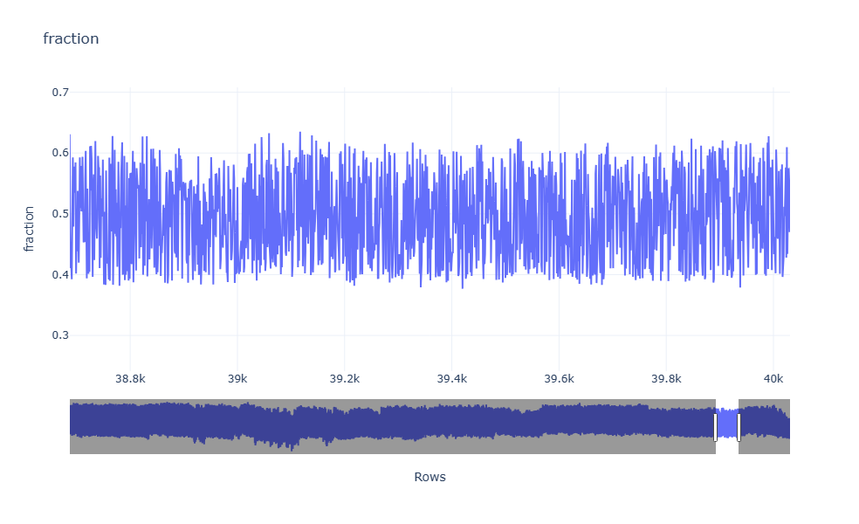

If we zoom

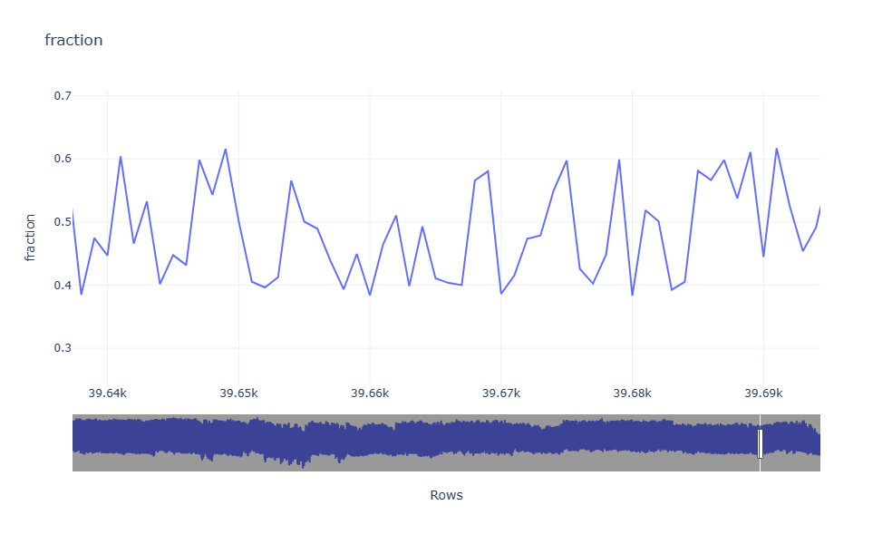

CA-Phase:

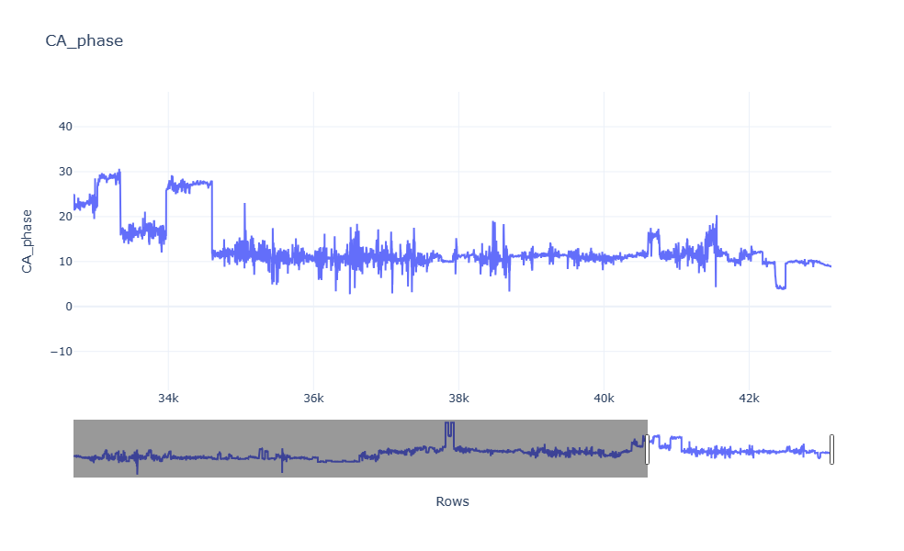

Zooming a bit:

